Nicola Cortesi, Michele Ducci, Alessandro Nobiletti, Alberico Parente
IDS S.p.a. - Airnavigation and Navaid Division

Marco Bucci, Oberdan Rancitelli
ENAV S.p.a. – Servizi Tecnici, Ingegneria

THE MIXED USE OF FLIGHT INSPECTION AND COMPUTER SIMULATION: THE ENAV EXPERIENCES WITH AIRNAS ®

June , 2002

ABSTRACT

Nowadays advance in computational electromagnetic and computer science has given the possibility to inspect the navaids installations constraints and modification via computer modeling. ENAV S.p.a. was one of the leading organizations in the above mentioned field, starting it's cooperation with IDS S.p.a. since 1994.
During these years IDS and ENAV experienced many common activities in the field of navaids siting design: since 1994 the nearly 100% of new navigations aids were installed with the help of the IDS computer modeling tools of the AIRNAS ® framework.
The AIRNAS ® framework was developed by IDS S.p.a. in order to execute the EMC analyses requested by its customers to determine the expected radioeletric performances of the new navaids equipments taking into accounts the interactions with surrounding environment (man made obstacles, terrain and other Tx/Rx equipments) before the system installation. In 2000 ENAV S.p.a. decided to supply its engineering division with a its own computational capability acquiring from IDS S.p.a. an AIRNAS ® system. The following paper will describe some of the experiences accumulated during the past years of the common IDS and ENAV collaboration.

THE AIRNAS ® HISTORY

The development of the AIRNAS ® system began between the late ‘80s and early ‘90s when IDS s.p.a. proposed to ENAV S.p.a. (named AAAVTAG at that time) the use of its prediction tools (developed and used since the 1982 in the navy EMC analysis field) for the solution of the e.m. problems related to the installation and the preservation of Ground/Air TLC systems, radio navigation aids and radars.
The collaboration with ENAV started with a benchmark project: the e.m. characterization of the GP equipment of the Napoli/Capodichino airport (ICAO code LIRN, IATA code NAP). ENAV supported IDS with the data relevant to the airport area, the technical data of the installed equipment and the flight checks of that equipment.
IDS s.p.a. executed the required numerical simulations, and was able to demonstrate the capabilities and the accuracy of its prediction tool that was named EMACS (ElectroMagnetic Airport Control and Survey). Since that trial activity the EMACS system was used as an IDS internal tool for the e.m. analysis and design of the installation of:
- 10 VOR/DME
- 6 ILS
- 12 ATC radar
- 6 SMR radars
- 3 weather radar
- 10 Air/Ground TLC
- 6 MLS
In 1993/1994 IDS s.p.a. granted from ENAV s.p.a. a contract for an automated Sw system for the instrument flight procedures design: the SIPRO system. The evolution of the SIPRO system was named FPDAM ® and is currently in use by more than 12 CAAs all over the world.
In the late ‘90s the IDS Airnavigation and Navaid Division was in charge of a powerfull e.m. tool (the EMACS system) and of a quite successful product for the instrument approach procedures design and airspace management (the FPDAM ®): the were the conditions for a more in depth integration of FPDAM ® and EMACS, and so it was created the AIRNAS ® system as a multi disciplinary modular design environment (Framework) based on CAD and simulation techniques capable of concurrently dealing with problems related to:
- the different phases of air navigation design (e.g.: en-route, landing, missed approach, etc.);
- data relevant to the airspace management (e.g.: FIR, ATM, ATZ, operative sectors, routes, navaids, …)
- the various tasks involved in system choices and performance evaluation of Navaid and ATC systems.
AIRNAS ® is composed by:
- an aeronautical Data Base, a GIS (compliant with aeronautical requirements);
- a 3D CAD (fully integrated to the GIS);
- a module library implementing the ICAO-PANS-OPS, the US TERPS and NATO STANAG APATC 1A design criteria
- a library of electromagnetic simulation tools to evaluate the interactions between R/Tx systems and the nearby environment.
AIRNAS ® is conceived to be capable of assisting both the AIS designer and the Navaid-ATM/ATC designer
As depicted in the conceptual scheme of Figure 1, AIRNAS ® is composed of the following major blocks:
- FPDAM ®: the Flight Procedure Design and Airspace Management is a three-dimensional CAD tool that provides an interactive environment for Aeronautical Flight Procedures design, Air Space management and Air Navigation using the new GPS based concepts. FPDAM ® takes into account all factors affecting flight procedure performance (airdrome terrain model, artificial obstacles, type of aircraft, ICAO Rules, GNSS satellite constellation etc.), within an interactive environment capable of ensuring a tight control on the system configuration and on all elements and design criteria related to flight safety issues;
- EMACS: ElectroMagnetic Airport Control and Survey is a set of validated electromagnetic 3D modelling and simulation tools, capable of coping with EMC (ElectroMagnetic Compatibility issues and EMI ElectroMagnetic Interference problems in airport and air navigation site scenarios. The modelling functionality (including terrain models, obstacles, interfering system, ground and airborne navaid equipment characteristics etc.) allows an expert user to model the propagation real phenomena taking place within a complex e.m. airport scenario where signals (VOR, DME, ILS, ATC Radar, GPS systems) interfere with artificial or natural obstructions;
- VESAS: Virtual Electromagnetic Satellite nAvigation Simulation system is an environment currently under development (planned for 3rd Q 2002) ehich is devoted to solve the major problems related to the aeronautical Satellite navigation. VESAS is composet of two working tools:
- SAPET (Satellite navigation Performance Evaluation Tool) is a simulation tool devoted to analyse the GNSS satellite constellation (GPS, GLONASS and geostationary), and is able to assess parameters such as satellite visibility (on fixed points, flight procedures and geographical area), DOP, …
- GEMS (GNSS EM virtual flight Simulation, currently under development) is a set of tools devoted to assess the electromagnetic characteristics of the satellite signals such as field strength, multipath, EMI, …
- Aeronautical Data Base for archiving all design relevant data and all elements concurring to the safety of flight procedures and Air traffic control;
- AIRNAS ® Cartographic and modeling tool to create the 3D models of the aeronautical environment

EXAMPLE CASES

1.- An ILS/LLZ case
The LLZ equipment of the Venezia/Tessera international airport (ICAO code LIPZ, IATA code VCE) experimented some problems that drove its signal very close (or slightly beyond) to the Cat. III course structure max. ratings. This problem was solved by means of an antenna recalibration plus flight checks, but no one was able to demonstrate if that problem was in way related to the construction of a new hangar within the airport area. The AIRNAS ® system, acting on a virtual model of the reality, was able to analyse the multipath contribution of each airport element separately from the other ones. The whole airport model was set-up and simulations were carried on in order to compare the measured data (both along the runway axis with a van and along the approach path with a ENAV S.p.a. flight inspection aircraft) with the computed one (see Figure 2). The goal of this simulation activity was the measure of the degree of accuracy of the numerical model of the airport: the numerical model of the Venice airport was judged good enough for the porpoise of the commissioned task. Starting from this model, two simplified airport models were created: the first one was the same of the complete one with the new hangar removed and the second one was only composed by the new hangar as it were the only building within the airport area.
The DDM curve relative to the first model showed only slight differences from the one taking into account the whole airport, and the DDM curve relative only to the new hangar showed scattering contributions of the LLZ signal in an area not relevant to the LLZ operations.

2. A VOR case
Many application examples of the AIRNAS/EMACS system can be cited, among them there is the Torino/Caselle (ICAO code LIMF, IATA code TRN) international airport case. This was the installation of a new equipment, so it was not possible a cross-check with flight measurements as in the case of the Venice LLZ. In this case were executed a sensibility analysis to inspect the stability of the solution (i.e. if the bearing error curve variation to parameters modification is many different parametric analyses varying some elements such as:
The airport infrastructures position
- The airport infrastructures dimensions
- The materials constituting the infrastructures
- The numerical techniques used for the simulation of the VOR signal interaction with the surrounding environment.
All those test showed minimum changes in the VOR signal parameters (essentially the signal strength and the bearing error), and this is the proof of a stable and then reliable solution.
Some months after the execution of those e.m. analyses, the execution of the commissioning flight check on the installed equipment made possible a comparison between measured and computed data (as shown in Figure 3), showing a good degree of agreement.
3. A DME case
When IDS started the design of the Sw module dedicated to the evaluation of the multipath effects on the DME signal, it was decided to ask for the support of the Avionics Engineering Center of Ohio University in order to set-up some test cases to test and validate that new module.
Within this frame AEC selected two measurement set-up which were used for such a purpose (see Figure 4 and Figure 5), and IDS used its Sw module in order to model the multipath effects on that equipments.

4. A RADAR case
The last example of the use of the AIRNAS/EMACS tool for the radar e.m. analysis is the Lamezia Airport case ().
ENAV s.p.a. is planning the installation of a new APP radar within the Lamezia airport area, so it was decided to perform the e.m. feasibility analysis of the installation of this equipment within the frame of the on-the-job training of the ENAV personnel to the use of the AIRNAS ® tools.
As shown in Figure 6 and in Figure 7 it was possible to asses the:
- Antenna pattern distortion due to the interaction with the airport infrastructures
- The radar radio coverage taking into account of the presence of both site obstacle and the terrain around the antenna location.
The radar analysis module is also able to evaluate the minimum safe altitude at which execute the commissioning flight checks taking into account of both the radio coverage volume and the aircraft’s obstacle clearance for a safe flight.

CONCLUSIONS

The AIRNAS ® tools is a system developed for:
- The design of instrument flight procedures and the management of the airspace data (AIRNAS/FPDAM ®)
- The analysis (by means of computational electromagnetic techniques) of the radioelectric performance of TLC equipments, radionavigation aids and radar systems (AIRNAS/EMACS).

This system has a close interaction with the instrument flight measurement data because:
- AIRNAS ® uses those data in order to validate the numerical models of the environment around the antenna under analysis;
- Increase the effectiveness of the commissioning flight inspection of new equipments because the numerical analysis is able to highlight the areas of the out-of-tolerance of the signal of that equipment;
- Reduce the need (or nearly eliminate) of use portable equipments in the case of radionavigation aids installation in critical sites;
- Increase the safety of the flight during the equipment inspection tanks to the ability of compute the obstacle clearance along with the volume of operation of the equipment under check.

ACKNOWLEDGEMENTS

The authors would express their sincere thanks to Capt. Giancarlo Gozzini and to all the other guys from the Reparto Radiomisure ENAV S.p.a. for their support during the past years of cooperation.

REFERENCES

1.- ICAO Annex 10 to the Convention on International Civil Aviation
2. ICAO Doc. 8071 “Manual on Testing of Radio Navigation Aids”
3. FAA Doc. 8200.1A “United States Standard Flight Inspection Manual”
4.- ICAO Doc. 8168: “Procedures for Air Navigation Services – Aircraft Operations (PANS-OPS)”
5.- Lettera di Ordinazione ENAV n. AV/AOT/DAO/2151 del 11/04/2000: Realizzazione di un sistema di seconda generazione (AIRNAS 1) per la progettazione, validazione e pubblicazione delle procedure strumentali di volo e della gestione degli spazi aerei, anche nel contesto della navigazione satellitare (GNSS)
6.- Avionics Engineering Center: Technical Memorandum OU/AEC 01-05TM00/AOSTA-RNAV/492/321 “Assessment of Ingegneria Dei Sistemi Distance Measuring Equipment Multipath Model”, February 2001
7.- Articolo ESA su ILS

FIGURES

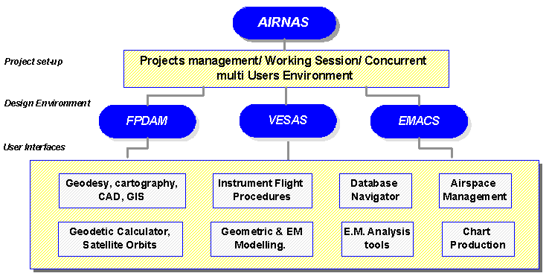

Figure 1: Conceptual scheme of the AIRNAS ® framework

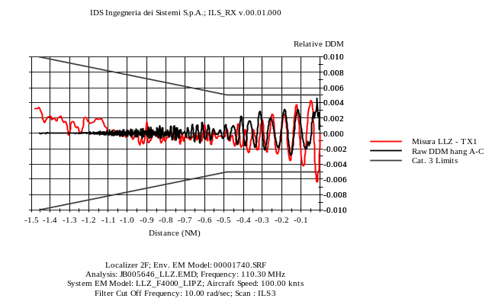

Figure 2: Venezia/Tessere LLZ DDM along the runway centerline

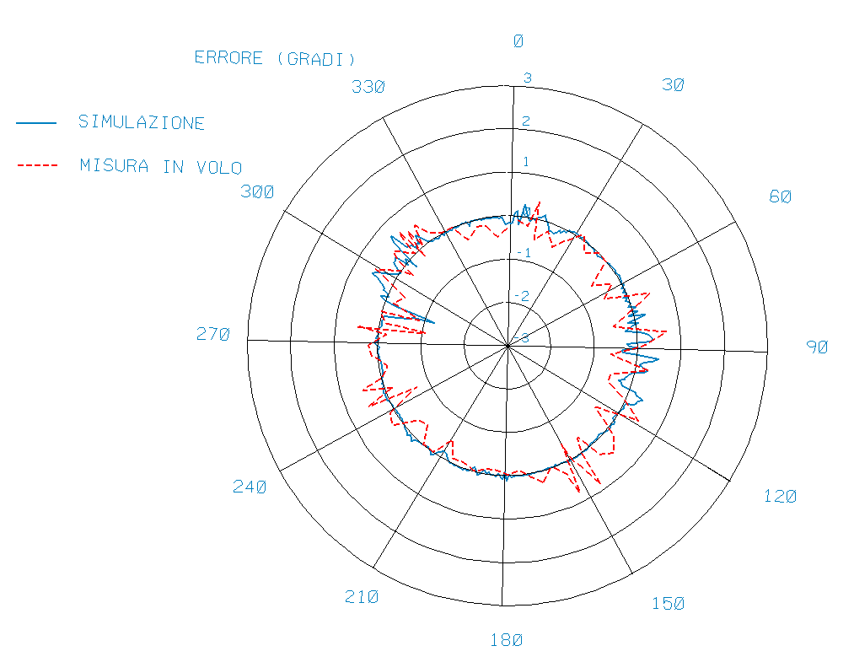

Figure 3: Computation/Measurement comparison of Torino/Caselle Airport DVOR bearing error

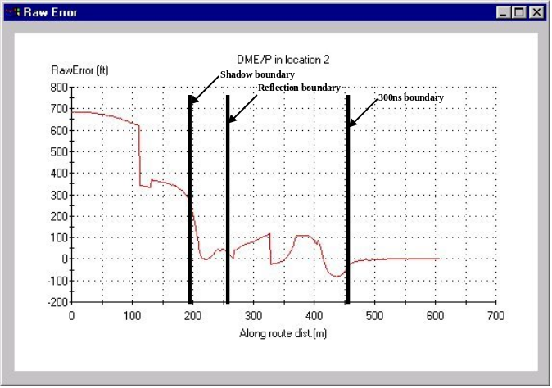

Figure 4: IDS S.p.a. Computed DME error

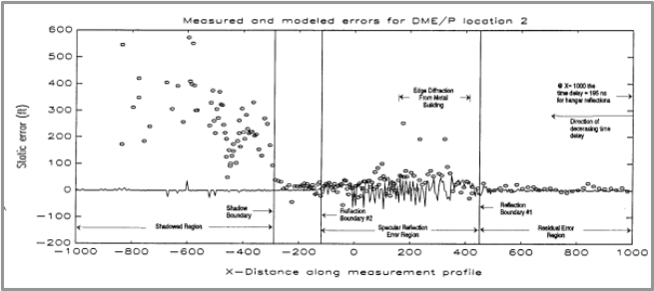

Figure 5: DME error measurements made by Avionics Engineering Center (Ohio Univ.)

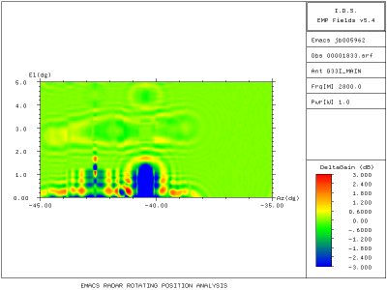

Figure 6: Example Lamezia APP radar antenna gain aberration prediction

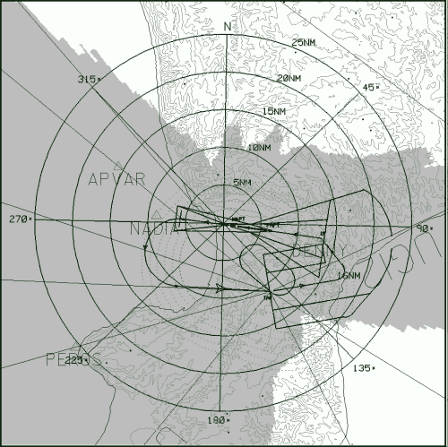

Figure 7: Example of Lamezia radar coverage prediction

